*LAB # 10*

*lab task*

*1. Write a MIPS assembly program that take input value and perform bitwise AND*

*instruction with mask 0.*

***CODE:***

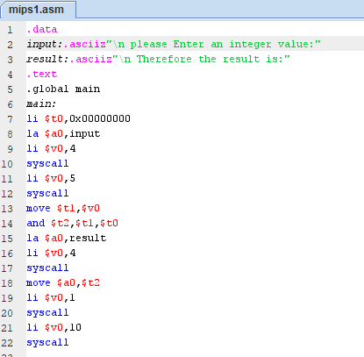

***EXECUTION:***

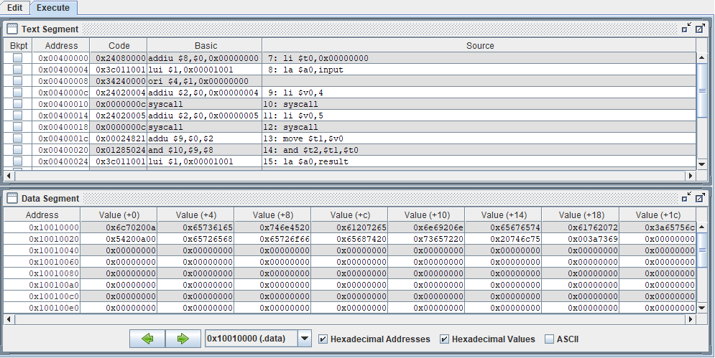

***OUTPUT:***

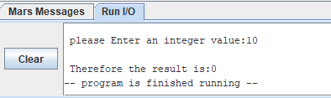

*2. Write a MIPS assembly program that take input value and perform bitwise OR*

*instruction with mask 0.*

***CODE:***

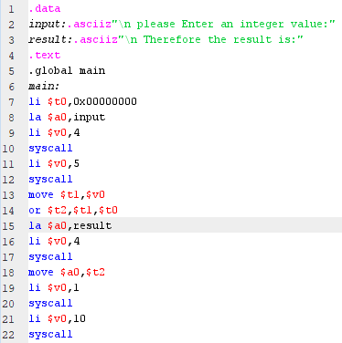

***EXECUTION:***

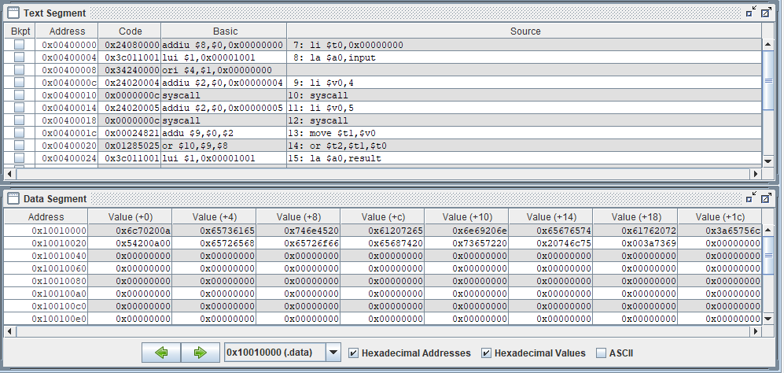

***OUTPUT:***

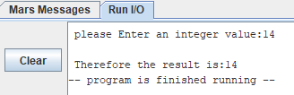

*3. Write a MIPS assembly program that take input value and perform bitwise OR*

*instruction with mask 1.*

***CODE:***

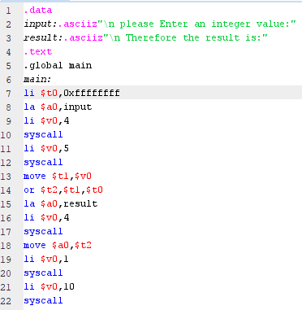

***EXECUTION:***

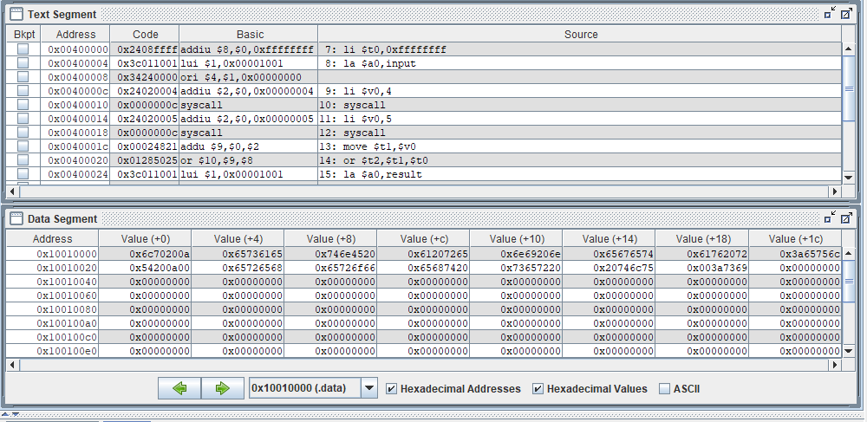

***OUTPUT:***

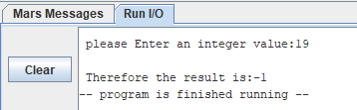

*4. Clear the sign bit of $t0 while leaving the other bits unchanged?*

***CODE:***

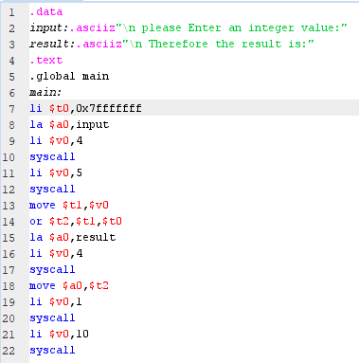

***EXECUTION:***

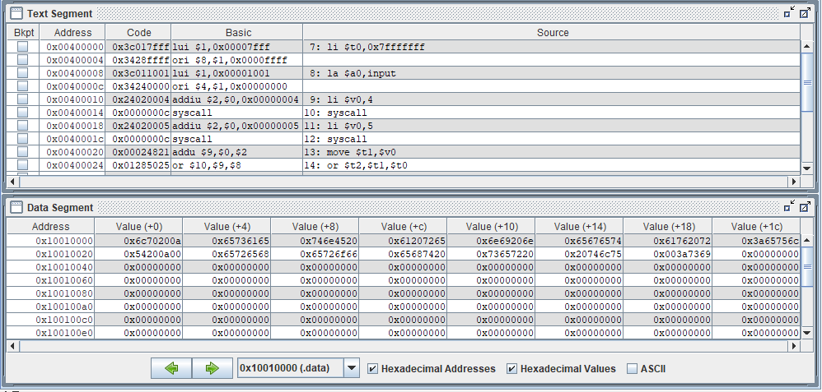

***OUTPUT:***

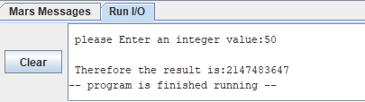

*5. Set the most significant and least significant bits of $t0 while preserving the*

*other bits?*

***CODE:***

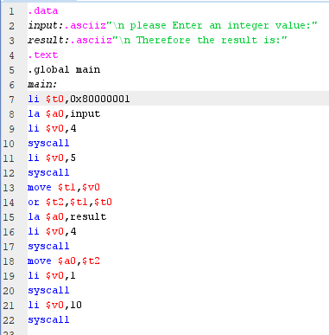

***EXECUTION:***

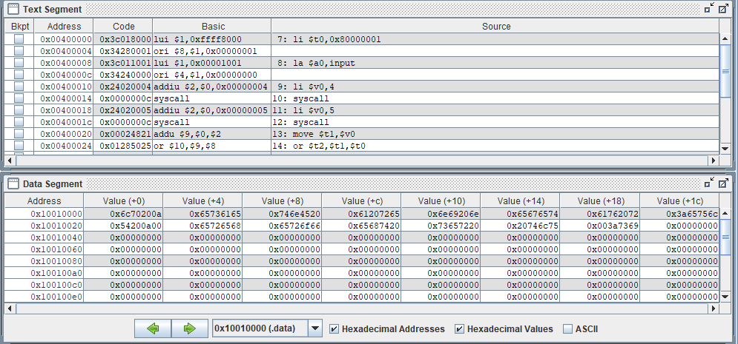

***OUTPUT:***

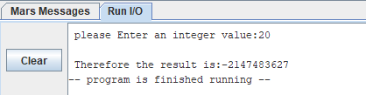

*6. Implement following circuit into MIPS Assembly Language using AND,OR*

*Instructions*

***CODE:***

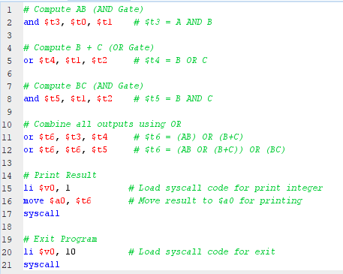

***EXECUTION:***

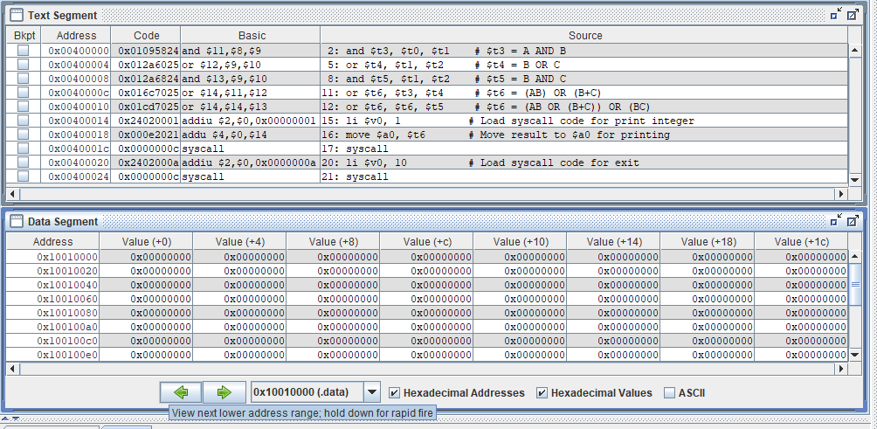

***OUTPUT:***

